Part of keeping healthy is reaching a balance between the energy you take in as food and the energy you use up.

Task

Use the information given about Sam’s diet and activity to answer the questions.
Breakfast
Glass of orange juice 153kJ | Bowl of cornflakes sugar and milk 700kJ | Slice of bread and butter 520kJ | Boiled egg 300kJ
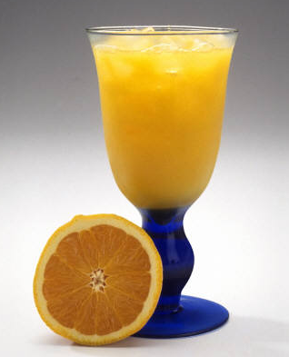 | 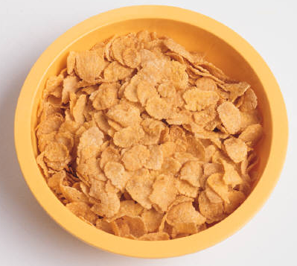 | 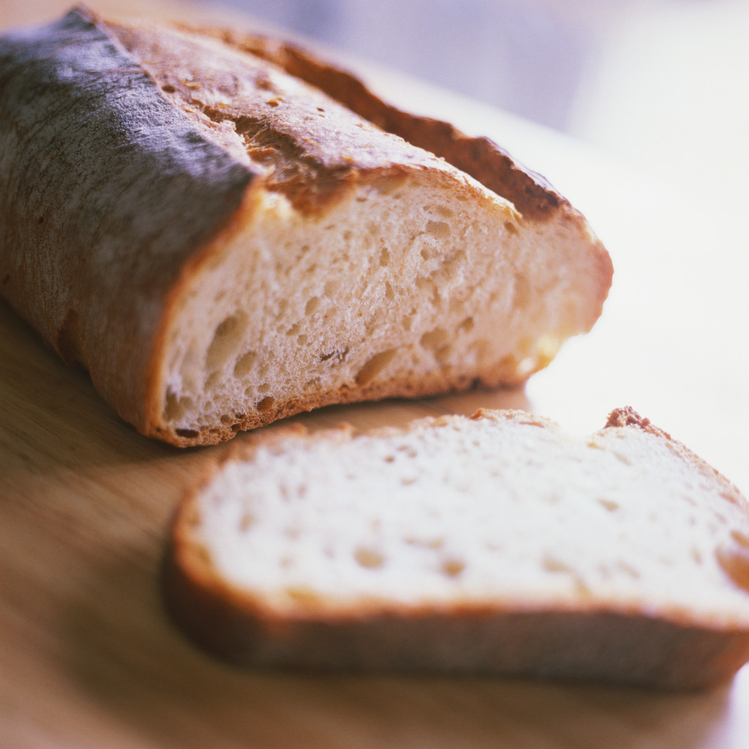 | 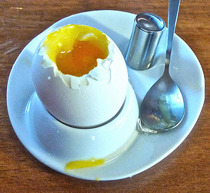

- How much energy would this breakfast give?

A table to show how much energy is needed (approximately) for some activities per hour.
Activity | Kilojoules per hour
lying down | 320
sitting | 360
standing | 400
walking quickly | 1,280
running | 1,640

- This is Sam’s morning. Complete the table, using the information above to show the energy Sam used.
Activity | Time (minutes) | Energy used (kJ)
walked to school | 30
stood around talking | 15
sat in lessons | 120
played sport (running) | 15

- How much energy did Sam use in total?
- Did the breakfast meet Sam’s energy needs? Why do you think this?

- Write down another factor, (other than level of activity), that would affect Sam’s energy needs.

- When lying down, what would the body use the 320KJ of energy for? List 3 things
a. | b. | c.

Answers

- 1673 KJ

Activity | Time (minutes) | Energy used (kJ)
Walked to school | 30 | 640
Stood around talking | 15 | 100
Sat in lessons | 120 | 720
Played Football (running) | 15 | 410

- 1870 KJ
- No because the energy taken in was less than the energy used. (It is only a small snapshot of Sam’s diet so difficult to draw a conclusion either way.)
- Body mass, external temperature, age, gender, proportion of muscle etc
- Growth, replacing cells, automatic body functions e.g. heart contraction, breathing, digestion, nervous system, making new compounds e.g. enzymes, hormones

Image Credits
© Larry & Ted Page 2010 http://www.flickr.com/photos/96029422@N00/4301970315/

